Assignment 1

Name : Shreyas Anil Dimbar

PRN : 245100140

Batch : S6

# Write a program to calculate Sum of greatest and least elements of an array.

Code :   
#include <stdio.h>

int main() {

int n;

scanf("%d", &n);

int arr[n];

for(int i = 0; i < n; i++)

scanf("%d", &arr[i]);

int min = arr[0], max = arr[0];

for(int i = 1; i < n; i++) {

if(arr[i] < min) min = arr[i];

if(arr[i] > max) max = arr[i];

}

printf("\n");

printf(" The sum is : %d", min + max);

return 0;

}

Output :

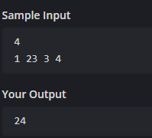

# Write a program to count the unique elements in array.

Code :

#include <stdio.h>

int main() {

int n, count = 0;

scanf("%d", &n);

int arr[n];

for(int i = 0; i < n; i++)

scanf("%d", &arr[i]);

for(int i = 0; i < n; i++) {

int isUnique = 1;

for(int j = 0; j < n; j++) {

if(i != j && arr[i] == arr[j]) {

isUnique = 0;

break;

}

}

if(isUnique)

count++;

}

printf("%d", count);

return 0;

}

Output :

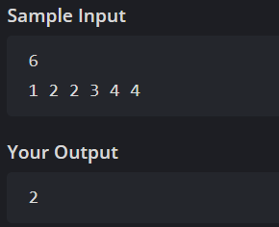

# Write a program to find missing element in an Array.

Code :

#include <stdio.h>

int main() {

int n, sum = 0, total;

scanf("%d", &n);

int arr[n - 1];

for(int i = 0; i < n - 1; i++) {

scanf("%d", &arr[i]);

sum += arr[i];

}

total = n * (n + 1) / 2;

printf("%d", total - sum);

return 0;

}

Output :

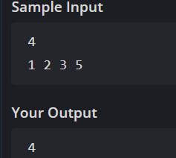

# Write a program to reverse an array

Code :

#include <stdio.h>

int main() {

int n;

scanf("%d", &n);

int arr[n];

for(int i = 0; i < n; i++) {

scanf("%d", &arr[i]);

}

for(int i = n - 1; i >= 0; i--) {

printf("%d ", arr[i]);

}

return 0;

}

Output :

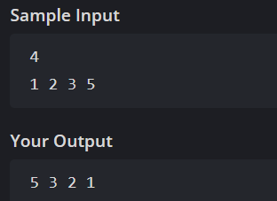

# 5.

Code :

#include <iostream>

#include <string>

#include <algorithm> // for std::swap

using namespace std;

struct student {

string name;

int id;

};

void sortStudents(student arr[], int n) {

for(int i = 0; i < n - 1; i++) {

for(int j = i + 1; j < n; j++) {

if(arr[i].id > arr[j].id) {

swap(arr[i], arr[j]);

}

}

}

}

student* solution(int N) {

static student arr[100];

for(int i = 0; i < N; i++) {

cin >> arr[i].name >> arr[i].id;

}

sortStudents(arr, N);

return arr;

}

int main() {

int n;

cin >> n;

student* s = solution(n);

for(int i = 0; i < n; i++) {

cout << s[i].name << " " << s[i].id << "\n";

}

return 0;

}  
output :

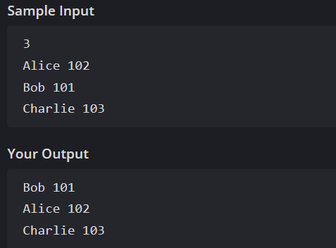

# 6.

Code :

#include <iostream>

using namespace std;

class Time {

public: int hours;

int minutes;

int seconds;

void read() {

cin >> hours >> minutes >> seconds;

}

};

void diff(Time t1,Time t2){

int total1 = t1.hours * 3600 + t1.minutes * 60 + t1.seconds;

int total2 = t2.hours * 3600 + t2.minutes * 60 + t2.seconds;

int diff = abs(total2 - total1);

int hrs = diff / 3600;

diff %= 3600;

int mnts = diff / 60;

diff %= 60;

int scnds = diff % 60;

cout << hrs << ":" << mnts << ":" << scnds<< endl;

}

int main() {

Time t1,t2;

t1.read();

t2.read();

diff(t1,t2);

}

Output :

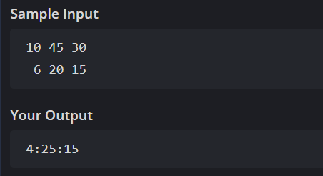

# 7.

Code :

#include <iostream>

using namespace std;

struct Product {

string name;

float price;

int quantity;

float totalCost() {

return price * quantity;

}

void read() {

cin >> name >> price >> quantity;

}

void print() {

cout << name << "\n";

cout << price << "\n";

cout << quantity << "\n";

cout << totalCost() << "\n";

}

};

int main() {

Product p;

p.read();

p.print();

return 0;

}

Output :

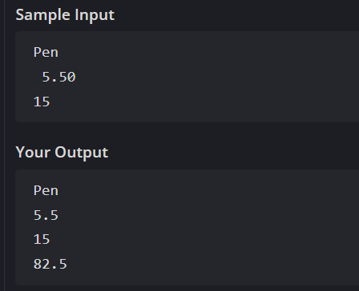

# 8.

Code :

#include <iostream>

using namespace std;

struct Item {

string name;

float price;

int quantity;

float total() {

return price * quantity;

}

};

int main() {

int C, N;

cin >> C >> N;

Item items[100];

float totalExpense = 0;

for(int i = 0; i < N; i++) {

cin >> items[i].name >> items[i].price >> items[i].quantity;

totalExpense += items[i].total();

}

float perPerson = totalExpense / C;

cout << totalExpense << endl;

cout << perPerson << endl;

for(int i = 0; i < N; i++) {

cout << items[i].name << " " << items[i].total() << endl;

}

return 0;

}

Output :

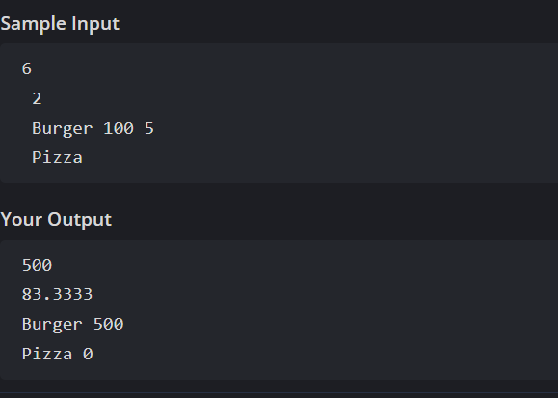

# 9.

Code :

#include <iostream>

using namespace std;

struct Measurement {

int inches;

float feet;

};

Measurement add(Measurement a, Measurement b) {

Measurement result;

result.inches = a.inches + b.inches;

result.feet = a.feet + b.feet;

return result;

}

int main() {

Measurement m1, m2;

cin >> m1.inches >> m1.feet;

cin >> m2.inches >> m2.feet;

Measurement total = add(m1, m2);

cout << total.inches << " " << total.feet << endl;

return 0;

}

Output :

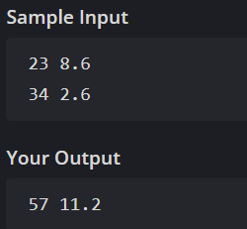

# 10.

Code :

#include <iostream>

using namespace std;

int main() {

int n, day, fine = 0;

cin >> n;

int cars[1000];

for(int i = 0; i < n; i++) {

cin >> cars[i];

}

cin >> day;

for(int i = 0; i < n; i++) {

if ((day % 2 == 0 && cars[i] % 2 != 0) || (day % 2 != 0 && cars[i] % 2 == 0)) {

fine += 250;

}

}

cout << fine << endl;

return 0;

}

Output :

